
NATIONAL
SENIOR CERTIFICATE
 |  |  |  | GRADE 11
NOVEMBER 2019
ENGLISH FIRST ADDITIONAL LANGUAGE P3
(EXEMPLAR)
MARKS: | 100
TIME: | 2½ hours
 |  |  | This question paper consists of 6 pages.

INSTRUCTIONS AND INFORMATION
1. | This question paper consists of THREE sections:  SECTION A: Essay (50)  SECTION B: Longer Transactional Text (30)  SECTION C: Shorter Transactional Text (20)
2. | Answer ONE question from EACH section.
3. | Write in the language in which you are being assessed.
4. | Start EACH section on a NEW page.
5. | You must plan (e.g. using a mind map/diagram/flow chart/key words etc.), edit and proofread your work. The plan must appear BEFORE each text.
6. | All planning must be clearly indicated as such. It is advisable to draw a line through all planning.
7. | You are strongly advised to spend approximately:  - 80 minutes on SECTION A  - 40 minutes on SECTION B  - 30 minutes on SECTION C
8. | Number the answers correctly according to the numbering system used in this question paper.
9. | Give each response a suitable title/heading.
10. | Do NOT consider the title/heading when doing a word count.
11. | Write neatly and legibly.

SECTION A: ESSAY
QUESTION 1
- Write an essay of between 200 and 250 words in length on ONE of the following topics.
- Write down the NUMBER and TITLE of the essay you have chosen correctly e.g. 1.1 The worst experience I ever encountered.
- Give your OWN title if your choice is QUESTION 1.7.1 OR 1.7.2.
- Spend approximately 80 minutes on this section.
1.1 | The worst experience I ever encountered |  | [50]
1.2 | I was healed ... |  | [50]
1.3 | Broken things should be repaired and used again |  | [50]
1.4 | ‘Do what is right, not what is easy …’ – Roy T. Bennett |  | [50]
1.5 | Mothers / Fathers are the best teachers |  | [50]
1.6 | Denial |  | [50]
1.7 | Choose ONE of the following pictures and write an essay on a topic that comes to mind. Write the question number (1.7.1 OR 1.7.2) and give your essay a suitable title.
 | NOTE: | There must be a clear link between your essay and the picture you have chosen.
 | 1.7.1 | 
 |  | [Source: photo essays pininterest] | [50]

 | 1.7.2 | 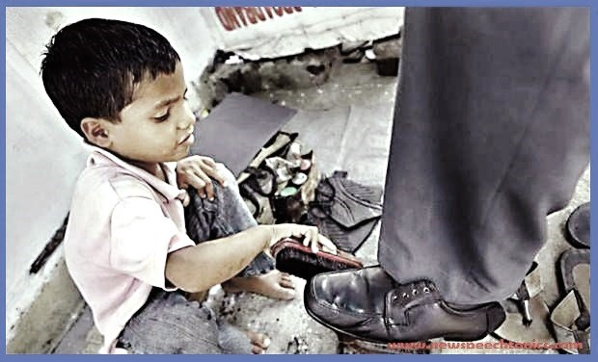
 |  | [Source: photoo.shop] | [50]
 |  | TOTAL SECTION A: | 50

SECTION B: LONGER TRANSACTIONAL TEXT
QUESTION 2
- Respond to ONE of the following transactional writing texts.
- The body of your response should be between 120 and 150 words in length.
- Write down the number and the heading of the text you have chosen, for example 2.1 FORMAL LETTER
- Pay particular attention to format, language and register.
- Spend approximately 40 minutes on this section.
2.1 | FORMAL LETTER
 | You were part of a touring sports team representing your school in another town. You sustained an injury that required medical attention. Then you were taken to the local hospital for treatment.
 | Write a letter to the hospital staff who treated you in which you thank them for their assistance when you were injured. | [30]
 | OR
2.2 | DIALOGUE
 | Your mother bought you a very expensive cellphone for your birthday. Due to your carelessness the phone went missing. You are afraid to inform her, because she warned you about losing the cellphone. At last you have courage to speak to her.
 | Write out the conversation that took place between yourself and your mother.
 | NOTE: Use the dialogue format. | [30]
 | OR
2.3 | INFORMAL REPORT
 | Recently you visited your local Animal Shelter. You were very worried to see the bad conditions in which animals live and the treatment given to them.
 | Write a report in which you outline what you saw and make suggestions on what should be done to improve the situation. | [30]
2.4 | OBITUARY
 | A grade eight learner had cancer and has passed away. The learner was very special to you. The family has asked you to do the obituary.
 | Write out the obituary, highlight what made him/her special to you and also pay tribute to him/her. | [30]
 | TOTAL SECTION B: | 30

SECTION C: SHORTER TRANSACTIONAL TEXT
QUESTION 3
- Choose ONE of the following topics and write a short text.
- The body of your response should be between 80 and 100 words in length.
- Write down the NUMBER and the HEADING of the text you have chosen, for example 3.1 INVITATION CARD.
- Spend approximately 30 minutes on this section.
3.1 | INVITATION CARD
 | Your grandmother is going to turn 90 years of age in the near future. Your family wants to organise a birthday party to celebrate this achievement.
 | Write out the invitation.
 | NOTE: No marks are awarded for drawings or illustrations. | [20]
 | OR
3.2 | DIARY ENTRIES
 | Your father has announced that your eldest brother is getting married and that a wedding ceremony will be held for him. He has also requested you to be the programme director at the wedding reception.
 | Write TWO dairy entries expressing how you felt BEFORE and AFTER the wedding reception. | [20]
 | OR
3.3 | INSTRUCTIONS
 | Your best friend is extremely excited about going on his/her first date and has asked you for advice.
 | Write out a set of instructions in which you advise him/her on how to behave during a date. | [20]
 | TOTAL SECTION C: | 20
 | GRAND TOTAL: | 100

